* **Mockito Hands-On Exercises**

**Exercise 1 : Mocking and Stubbing**

**Pom.xml**

<project xmlns="http://maven.apache.org/POM/4.0.0"

xmlns:xsi="http://www.w3.org/2001/XMLSchema-instance"

xsi:schemaLocation="http://maven.apache.org/POM/4.0.0

http://maven.apache.org/xsd/maven-4.0.0.xsd">

<modelVersion>4.0.0</modelVersion>

<groupId>com.example</groupId>

<artifactId>MockitoExample</artifactId>

<version>1.0-SNAPSHOT</version>

<dependencies>

<!-- JUnit 5 -->

<dependency>

<groupId>org.junit.jupiter</groupId>

<artifactId>junit-jupiter</artifactId>

<version>5.9.1</version>

<scope>test</scope>

</dependency>

<!-- Mockito -->

<dependency>

<groupId>org.mockito</groupId>

<artifactId>mockito-core</artifactId>

<version>4.8.0</version>

<scope>test</scope>

</dependency>

</dependencies>

<build>

<plugins>

<!-- Surefire plugin for running JUnit 5 -->

<plugin>

<groupId>org.apache.maven.plugins</groupId>

<artifactId>maven-surefire-plugin</artifactId>

<version>2.22.2</version>

<configuration>

<includes>

<include>**/*Test.java</include>

</includes>

</configuration>

</plugin>

</plugins>

</build>

</project>

**ExternalApi.java**

package com.example.mockito;

public interface ExternalApi {

String getData();

}  
  
**MyService.java**  
  
package com.example.mockito;

public class MyService {

private final ExternalApi api;

public MyService(ExternalApi api) {

this.api = api;

}

public String fetchData() {

return api.getData();

}

}

**MyServiceTest.java**  
  
package com.example.mockito;

import org.junit.jupiter.api.Test;

import static org.mockito.Mockito.*;

import static org.junit.jupiter.api.Assertions.*;

public class MyServiceTest {

@Test

public void testExternalApi() {

ExternalApi mockApi = mock(ExternalApi.class);

when(mockApi.getData()).thenReturn("Mock Data");

MyService service = new MyService(mockApi);

String result = service.fetchData();

assertEquals("Mock Data", result);

}

}

**OUTPUT**

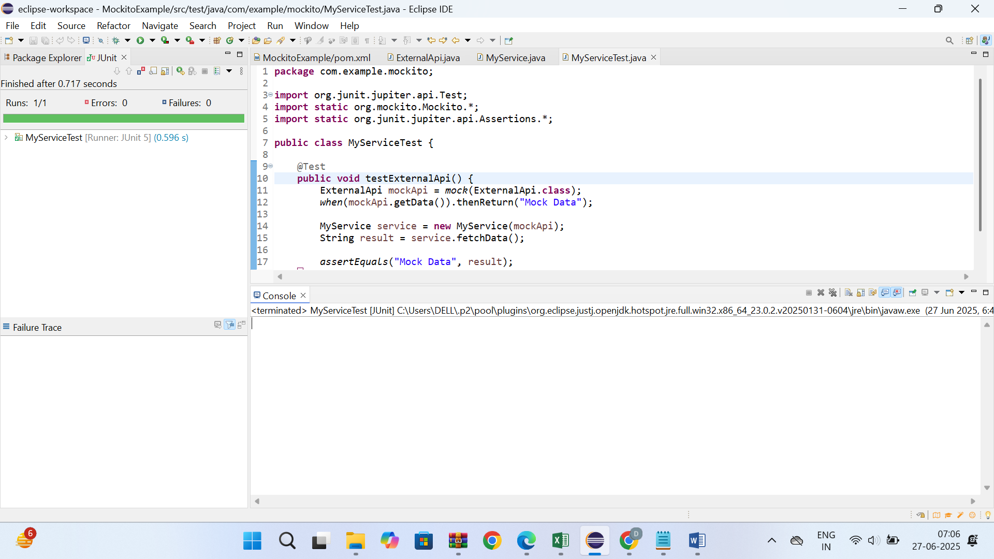

* **Exercise 2: Verifying Interactions**

**Pom.xml**

<project xmlns="http://maven.apache.org/POM/4.0.0"

xmlns:xsi="http://www.w3.org/2001/XMLSchema-instance"

xsi:schemaLocation="http://maven.apache.org/POM/4.0.0

http://maven.apache.org/xsd/maven-4.0.0.xsd">

<modelVersion>4.0.0</modelVersion>

<groupId>com.example</groupId>

<artifactId>MockitoInteractionExample</artifactId>

<version>1.0-SNAPSHOT</version>

<dependencies>

<dependency>

<groupId>org.junit.jupiter</groupId>

<artifactId>junit-jupiter</artifactId>

<version>5.9.1</version>

<scope>test</scope>

</dependency>

<dependency>

<groupId>org.mockito</groupId>

<artifactId>mockito-core</artifactId>

<version>4.8.0</version>

<scope>test</scope>

</dependency>

</dependencies>

<build>

<plugins>

<plugin>

<groupId>org.apache.maven.plugins</groupId>

<artifactId>maven-surefire-plugin</artifactId>

<version>2.22.2</version>

</plugin>

</plugins>

</build>

</project>

**ExternalApi.java**

package com.example.mockito;

public interface ExternalApi {

String getData();

}

**MyService.java**

package com.example.mockito;

public class MyService {

private final ExternalApi api;

public MyService(ExternalApi api) {

this.api = api;

}

public String fetchData() {

return api.getData();

}

}

**MyServiceTest.java**

package com.example.mockito;

import org.junit.jupiter.api.Test;

import static org.mockito.Mockito.*;

public class MyServiceTest {

@Test

public void testVerifyInteraction() {

ExternalApi mockApi = mock(ExternalApi.class);

MyService service = new MyService(mockApi);

service.fetchData();

verify(mockApi).getData();

}

}

**OUTPUT**

